MedCommons Affiliate Starter KIT

MASK lets you set up a branded service provider business “right out of the box” by providing all of the necessary hardware and software components to allow you to plug in your DICOM modalities and workstations to a pre-configured Collaborative MedCommons Subnet. Or you can use it as a Starter Kit for integrating into your existing operations or into your own product line.

MASK enables the rapid development and deployment of a Collaborative MedCommons Subnet amongst a group of cooperating enterprises that need to store, share, and modify Studies and Folders in support of applications such as Clinical Trials, 2nd Opinions and CAD Services. The MASK package is for institutional affiliates (e.g. hospital networks) that wish to embed the MedCommons Platform and Network into their healthcare projects, allowing them to concentrate on medicine and not worrying over telecommunications, HIPAA, DICOM, FDA approvals, and other hurdles to rapid project deployment.

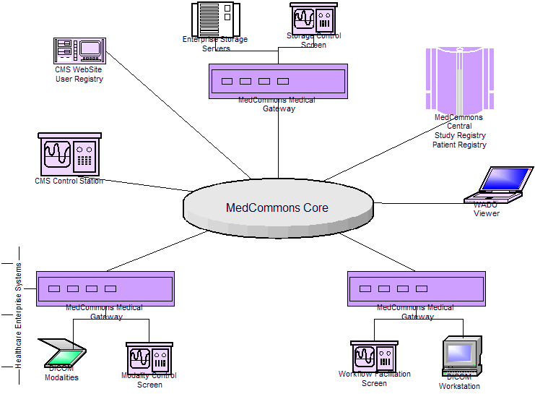

This diagram shows a simple collaborative subnet for an Affiliate application named CMS built directly out of the MASK package . An IT Integrator can use MASK to create a customized application for you.

To get your application rolled out:

1) Establish your subnetwork:

- Order one or two MedCommons Medical Gateway Subscriptions for each modality cluster that you wish to interconnect.
- Optionally order one or two MedCommons Medical Gateway Subscriptions for each storage repository you wish to interconnect
- Order one or two MedCommons Medical Gateway Subscriptions for each Cluster of DICOM workstations that you wish to interconnect
- Preferably, open enterprise firewalls to accept incoming connections into the MedCommons Medical Gateways you have ordered.

1) Extract the Basic Affiliate Website from the MASK package. Change the single logo file to your Affiliate Logo. Edit the Affiliate Properties file to supply your Affiliate name. Integrate the WebPages into any website of your choosing, or point Apache directly at the MASK package to just test that all is in order.

2) Extract the Basic Affiliate Database from the MASK package. The standard database consists of Patient and Physician tables with a basic web interface for table maintenance and sign-on/sign-off to the Affiliate All source code is provided to allow for extension.

3) Run the MedCommons IVP Suite to verify correct installation of all components

These software components are provided by MedCommons for the benefit of Affiliates

- MedCommons Service Provider Workflow Facilitator - allows 2nd Opinion or CAD Provider to monitor incoming and outgoing work queues and to prioritize items for workflow
- MedCommons Monitoring Tools – to observe CMS Gateways and MedCommons Central sites
- MedCommons Transfer Utility - allows moving studies between Gateways manually at customer discretion
- MedCommons LDAP Physician Registry Import Utility
- MedCommons Default Replicator – replicates patient folders between storage repositories.

